GitHub Setting Note

Firstly, Fork the repo from the owner

When you want to send your web repo to owner’s repo(main repo)

1. Sysnc the repo to the local using “github for windows”

2. Improve the project in the local git repo(coding)

3. Sysnc the local to your web github repo

4. In your web github, send “pull request” to the owner(Recipebank/RecipeBankGitHub)

5. Wait Micheal to check the code and handle your request

When you want to update your web repo from owner’s repo(main repo)

1. In web github, create the “pull request”

2. Change the “head fork” to owner’s repo(Recipebank/RecipeBankGitHub) and “base fork” to your repo. (Select the correct branch, which branch you want to send to owner and which owner’s branch you want to send the code to)

3. Click “create the pull request” and write down your update note.

4. Send the request to the owner

This is the “Recipebank” overview

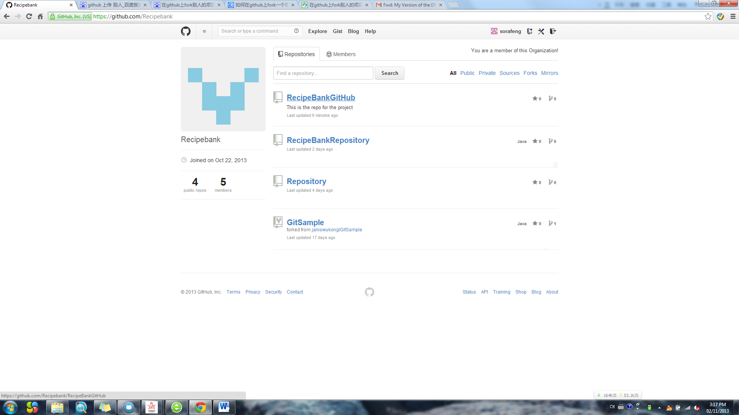

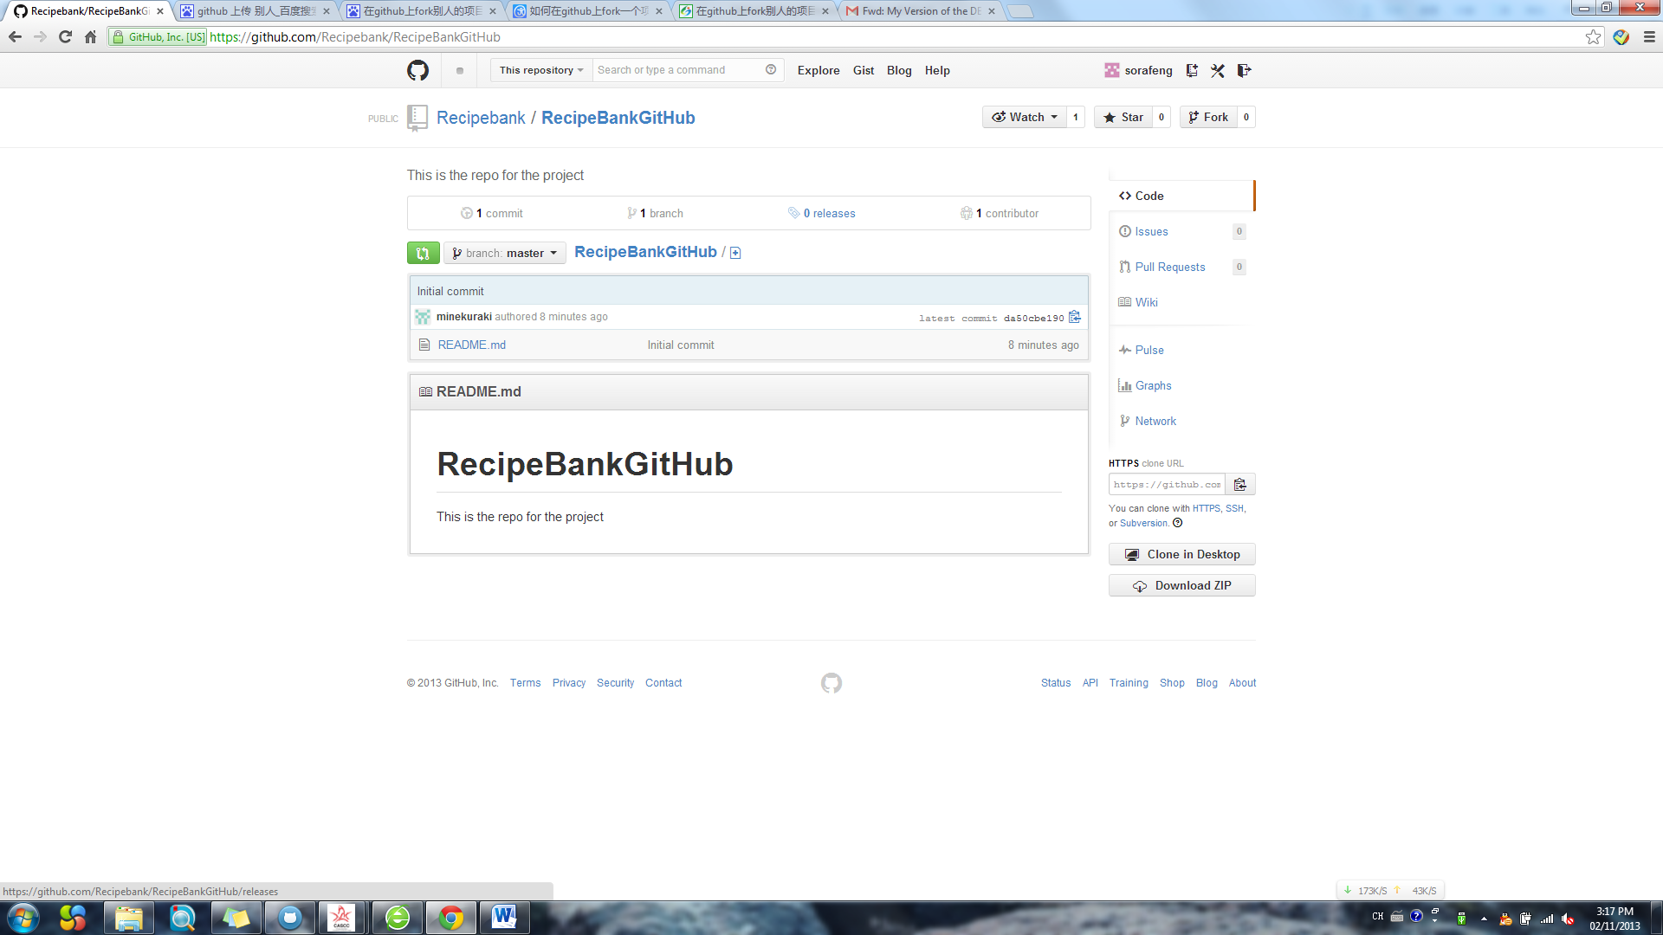

Fork The Team Project ”RecipeBankGitHub”

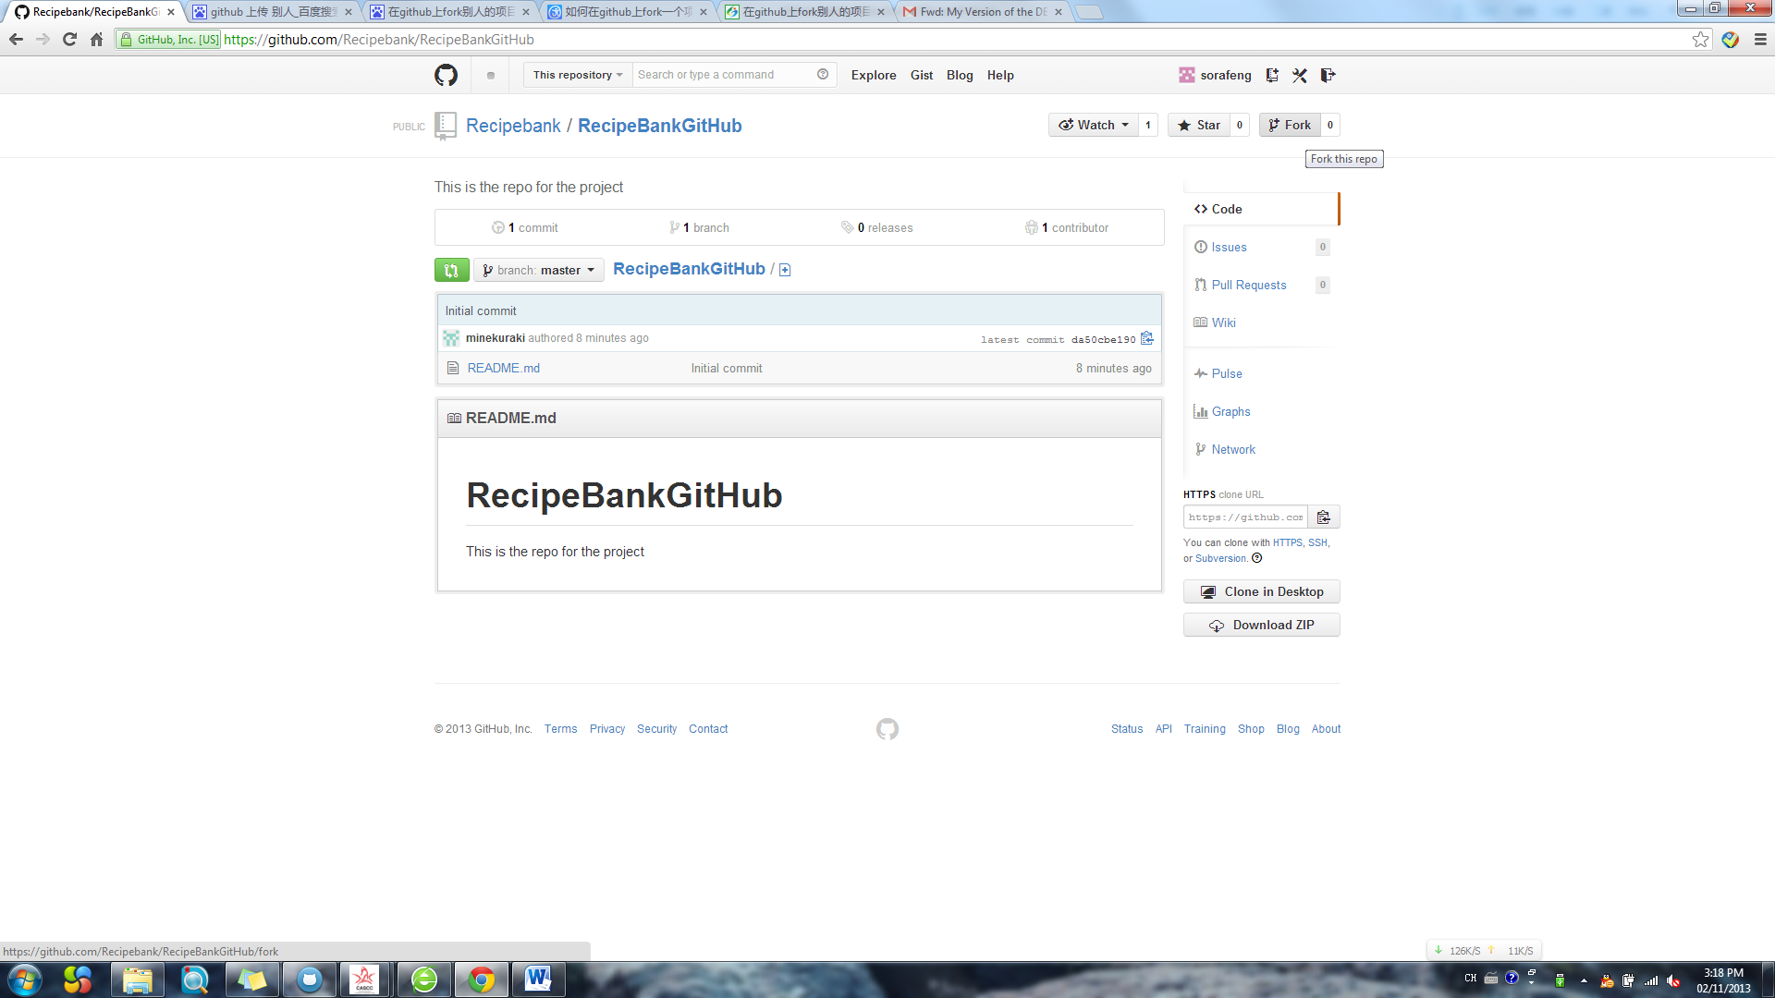

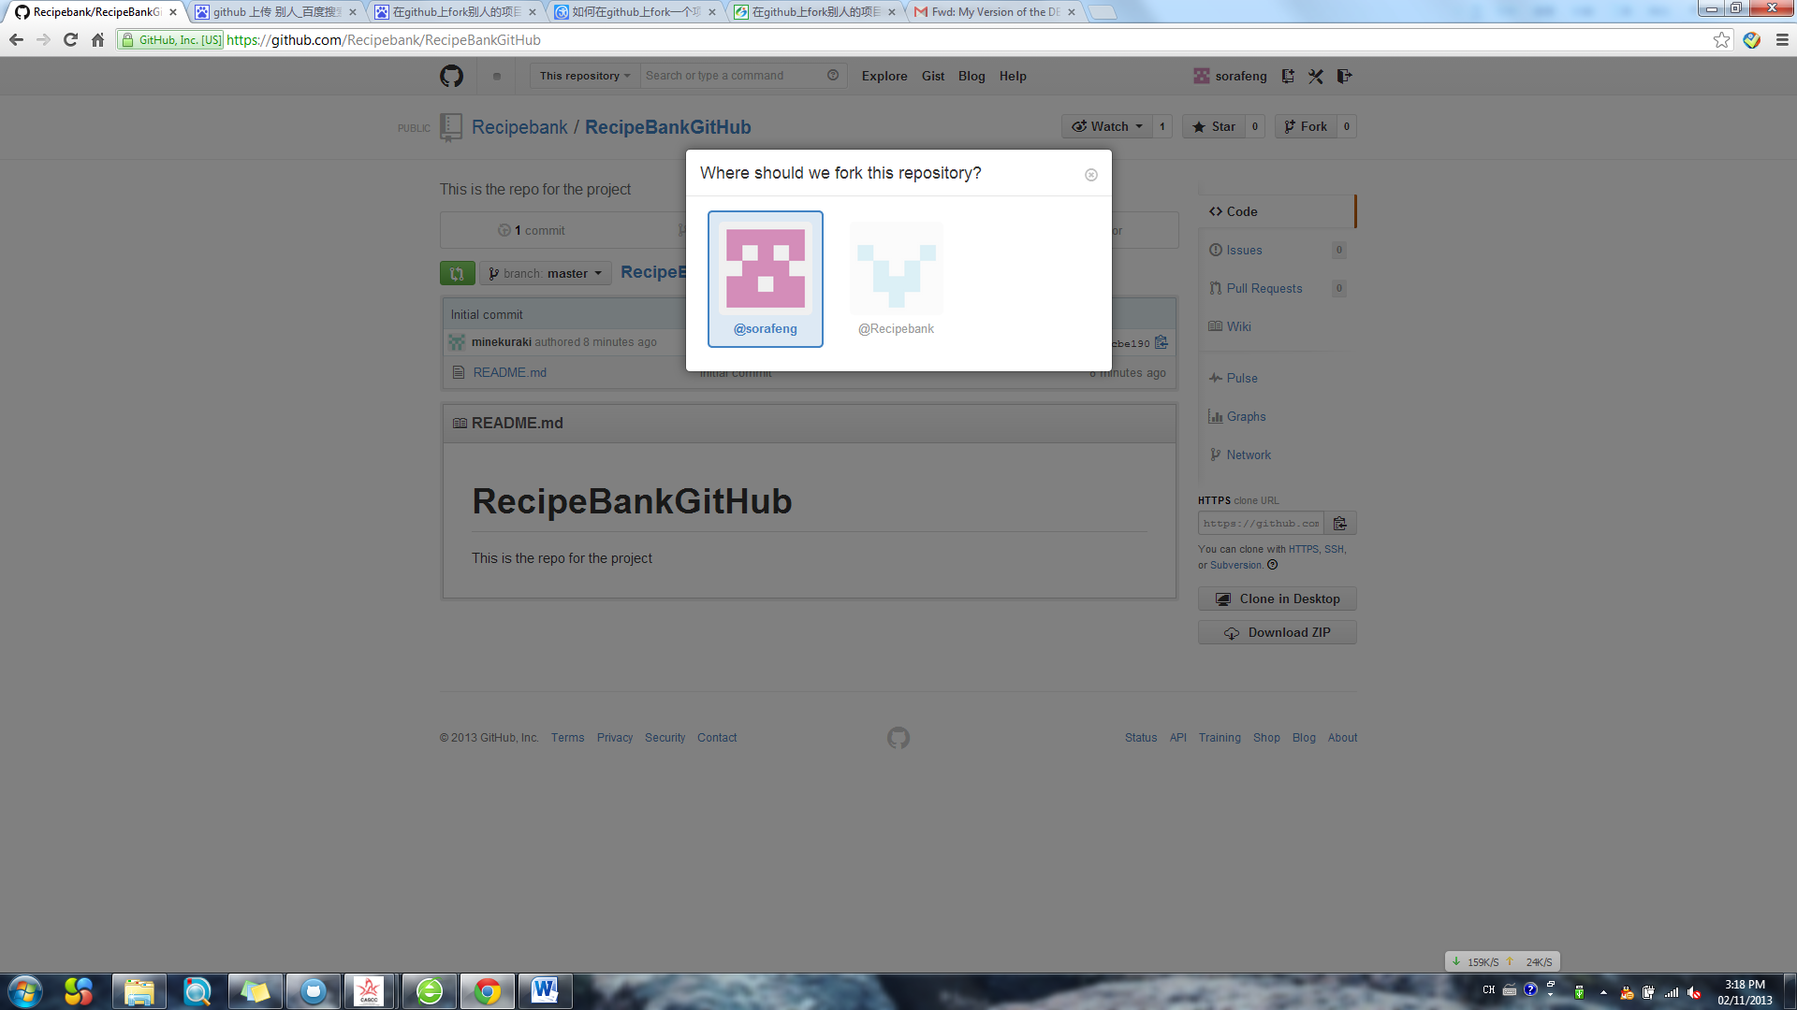

Successfully, you have the copy of the team project in your account

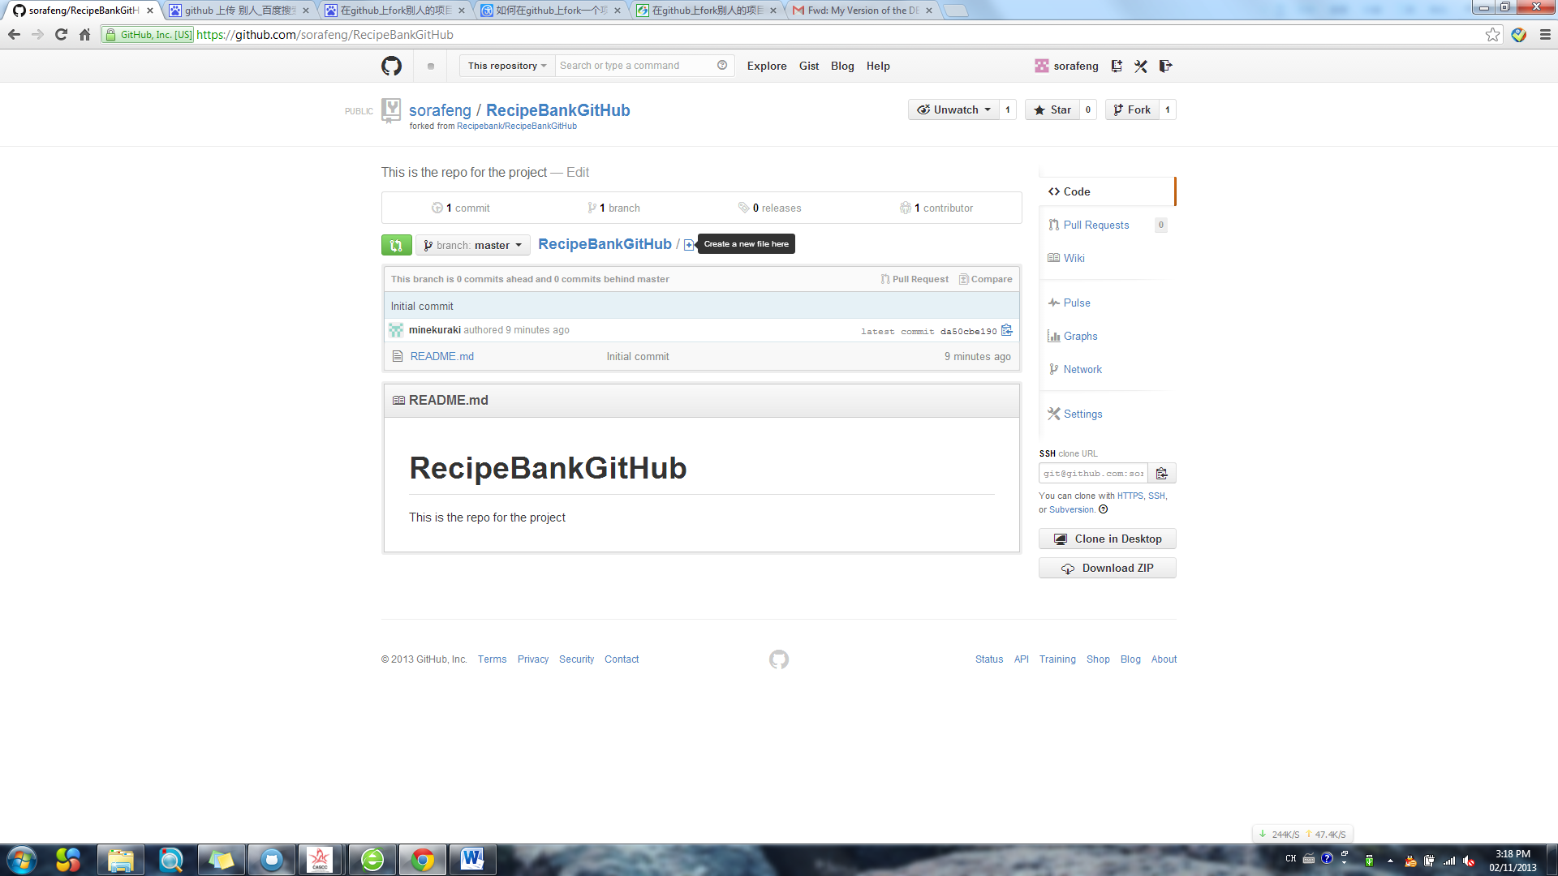

Use the Github for Windows Clone the repo

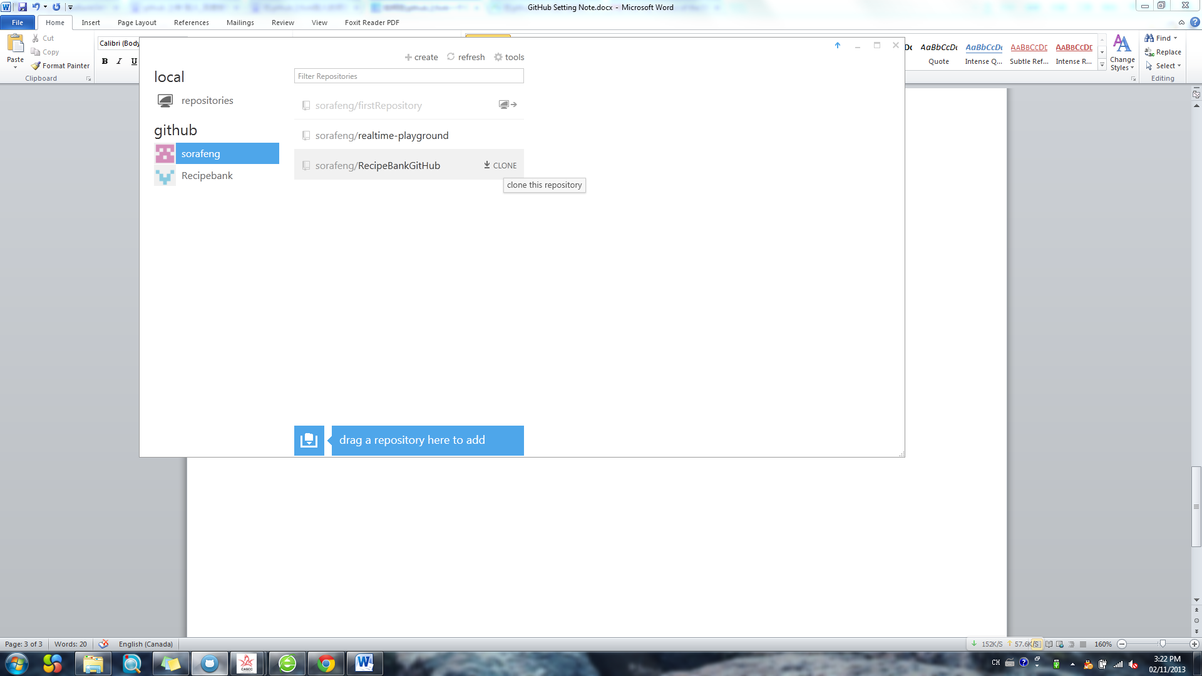

Already in local

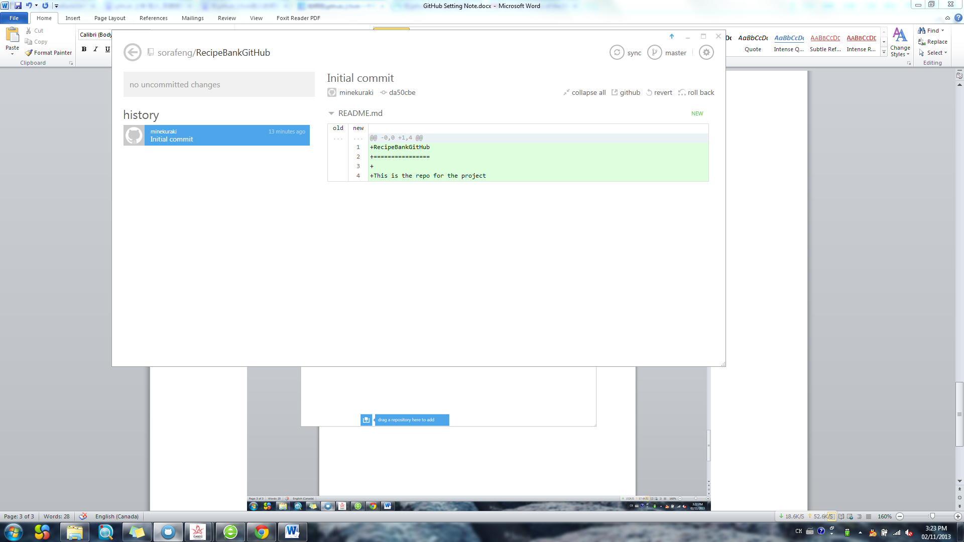

Opean Eclipse ADT

Open view “Git Respo…”

Choose “Add an existing local git repo… ”.

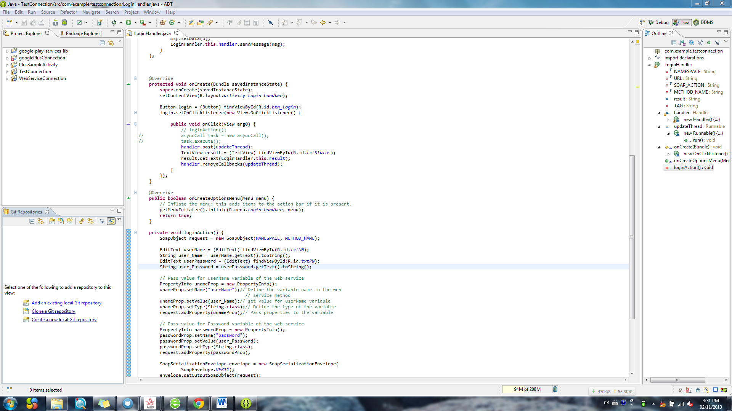

Choose the address where u store the repo

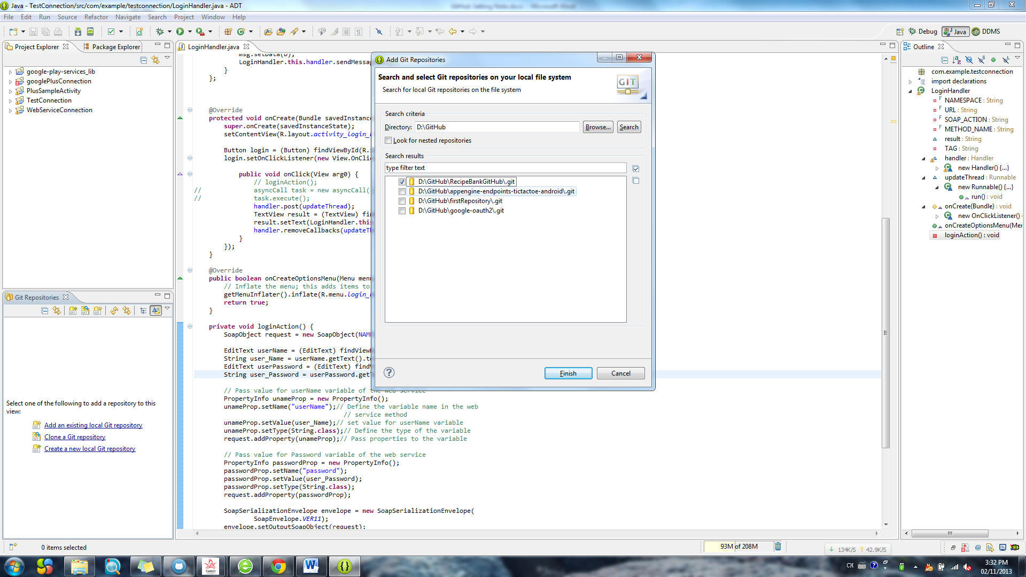

Click ”Finish”

Now we have the

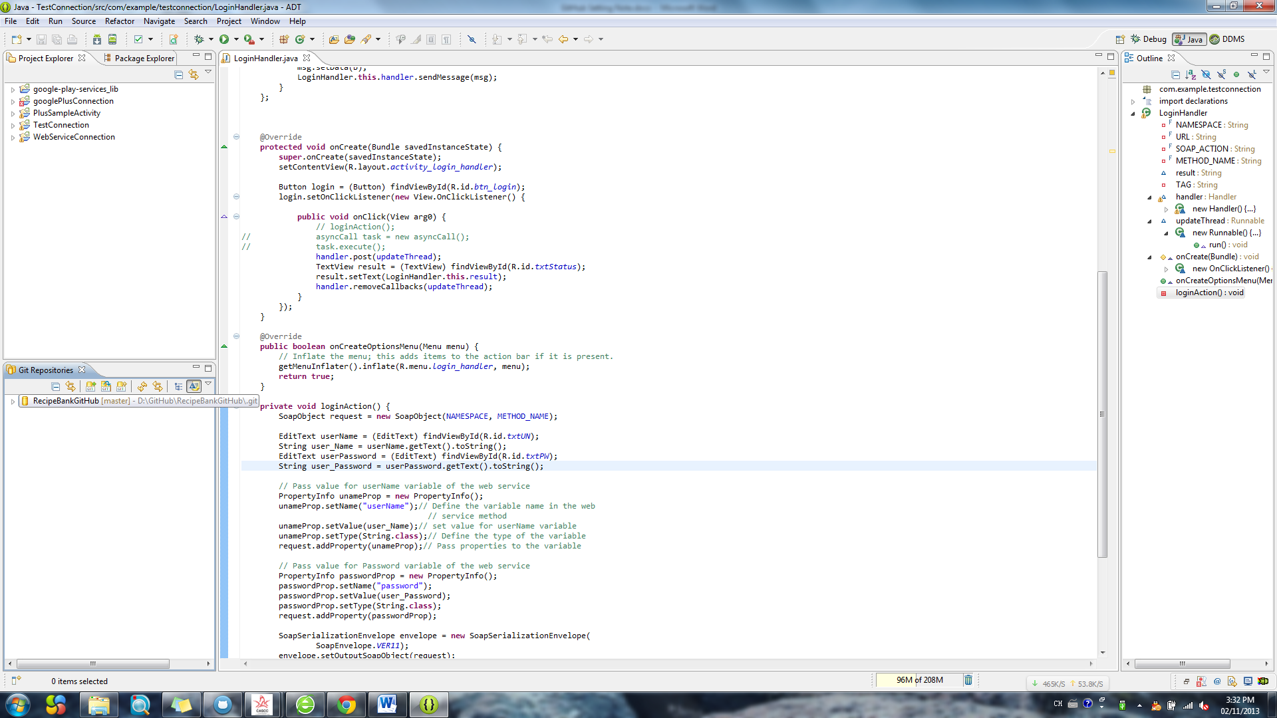

Now, if u want to commit the project to the repo which is in your local

Choose “Team”-> “Share project”

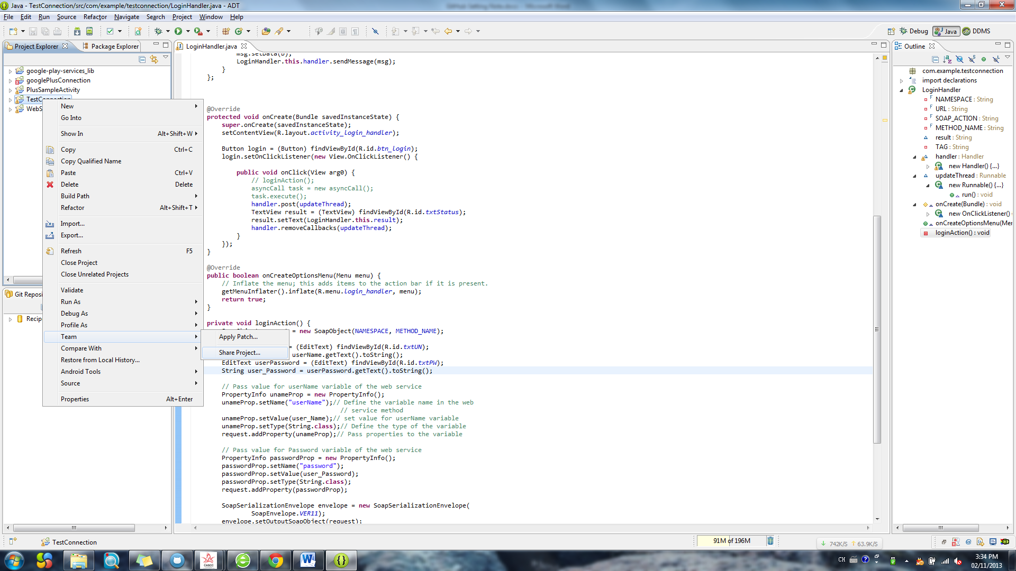

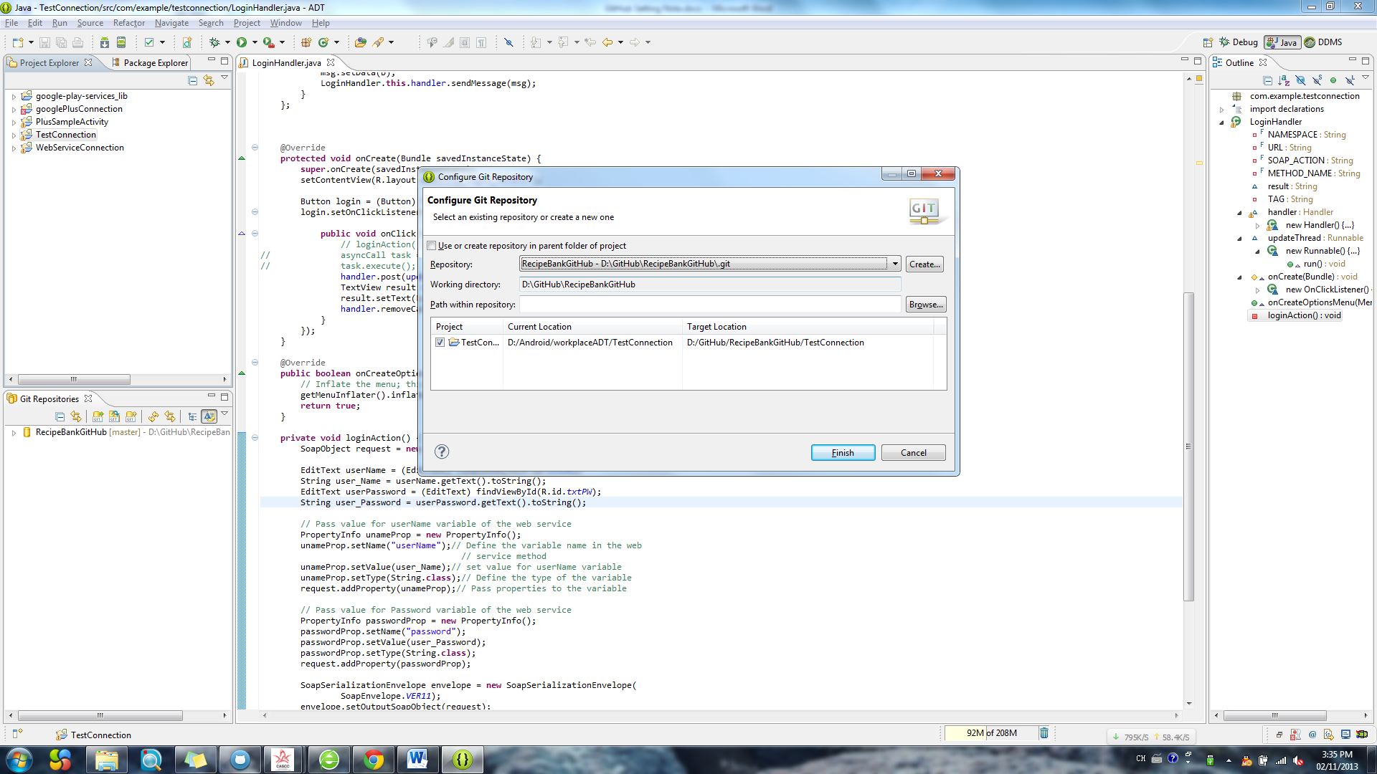

Add Success

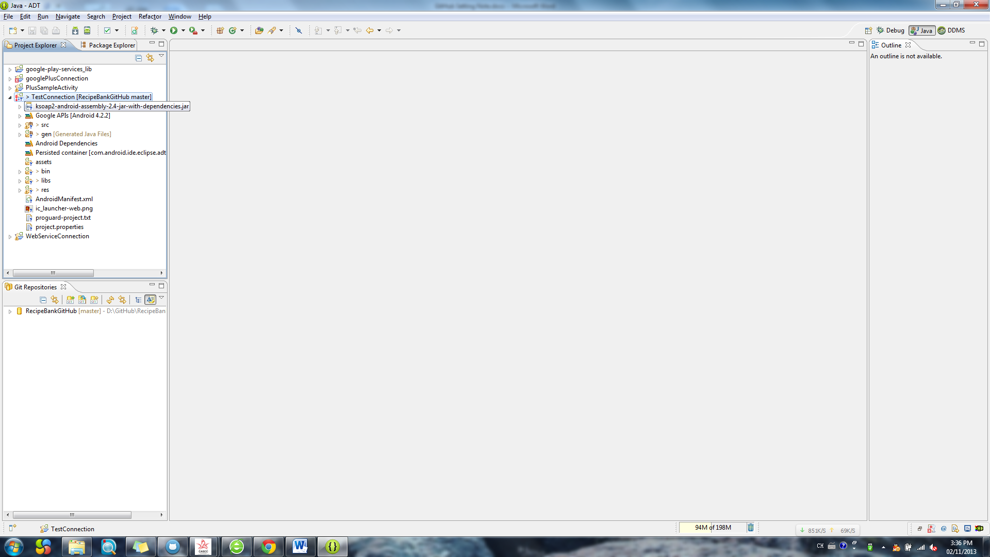

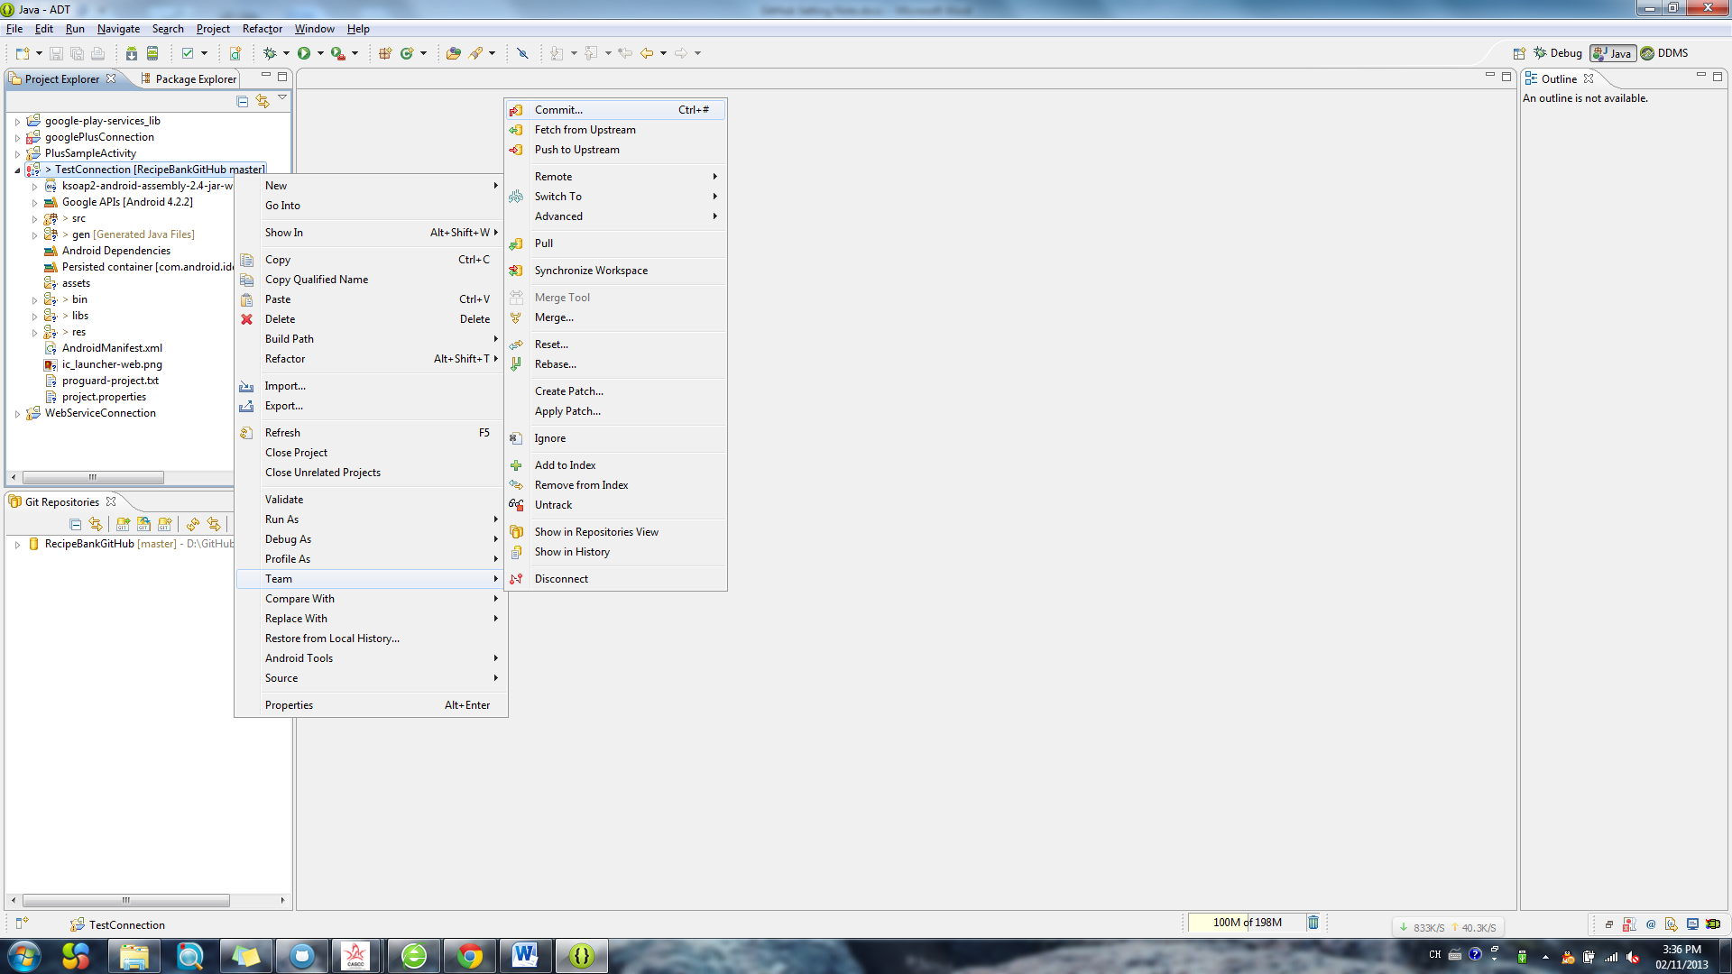

Select all and add comment

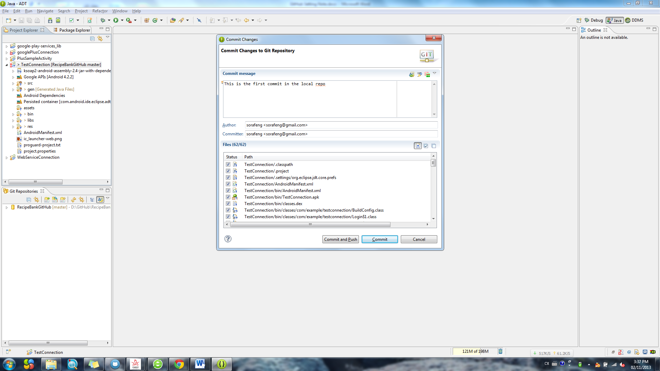

Choose “Commit ” will commit the project to the local repo

Choose “Commit and push” will commit the project to local repo and push to your web Storage.

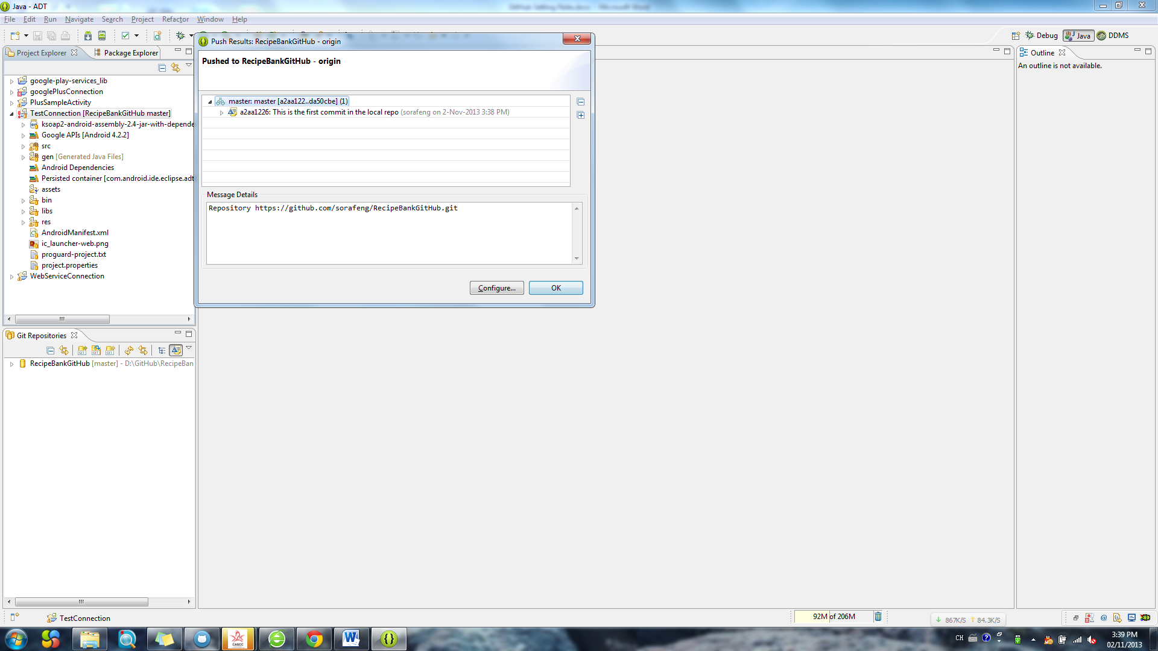

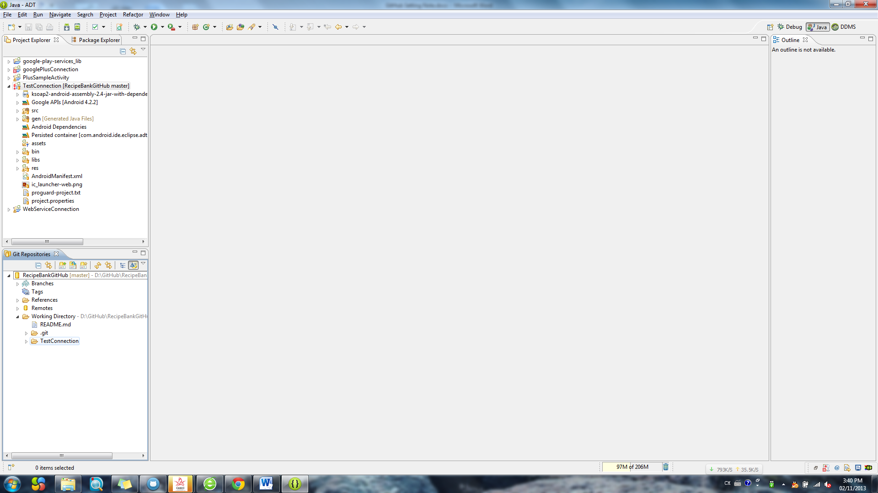

Now, go to the github web and see what happened

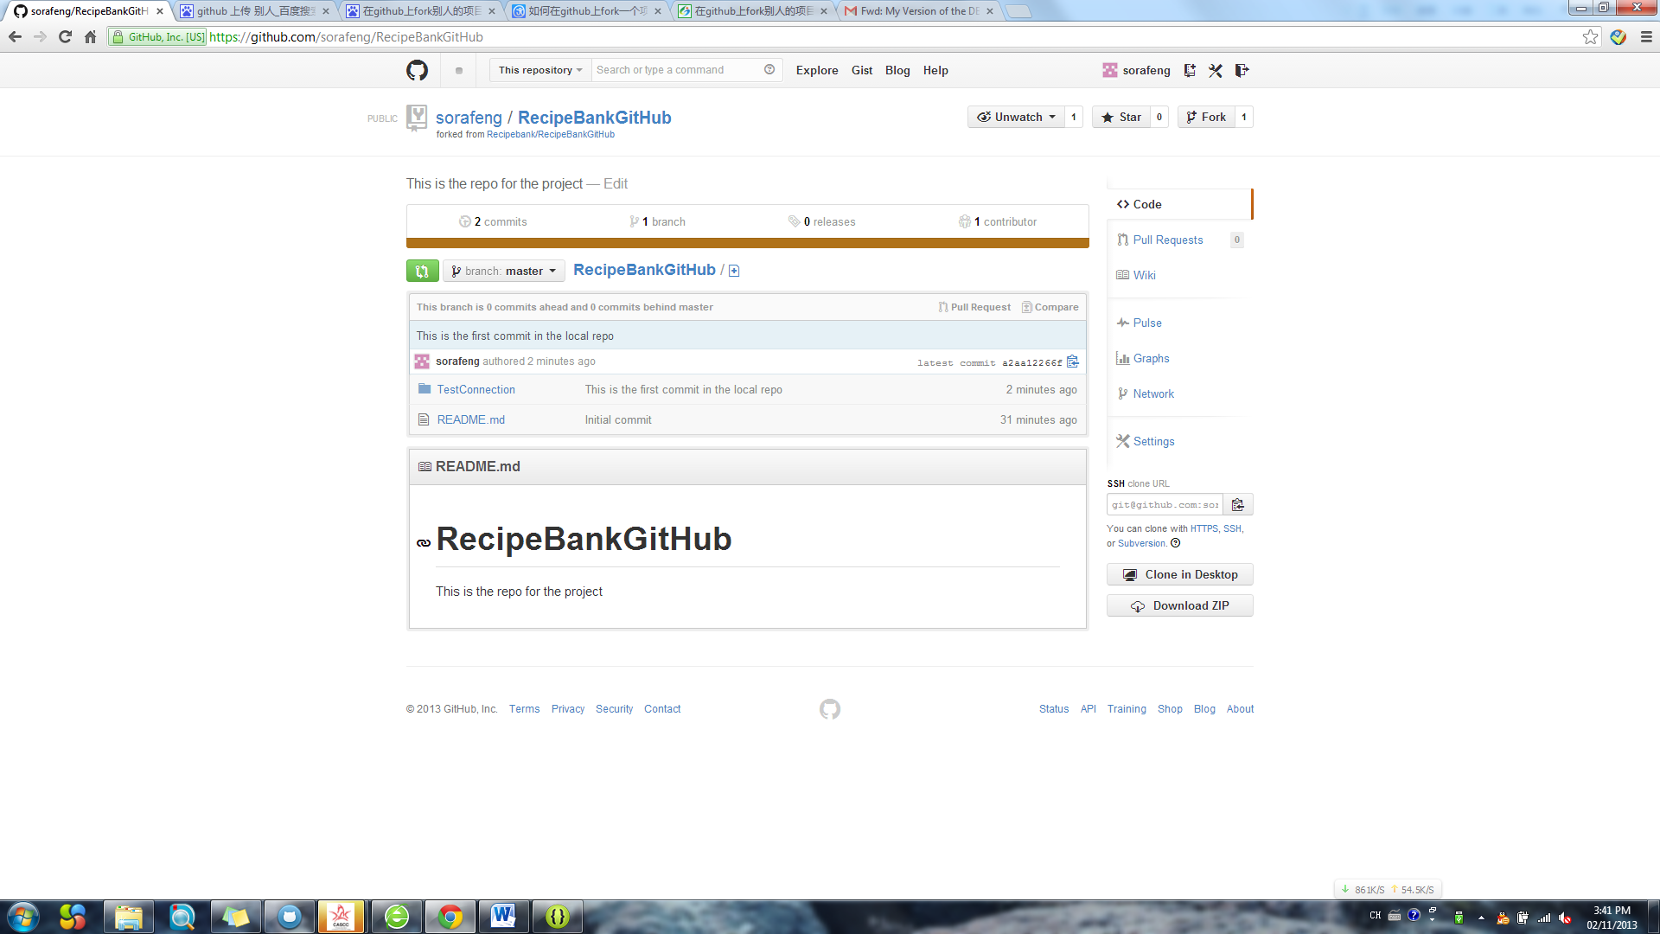

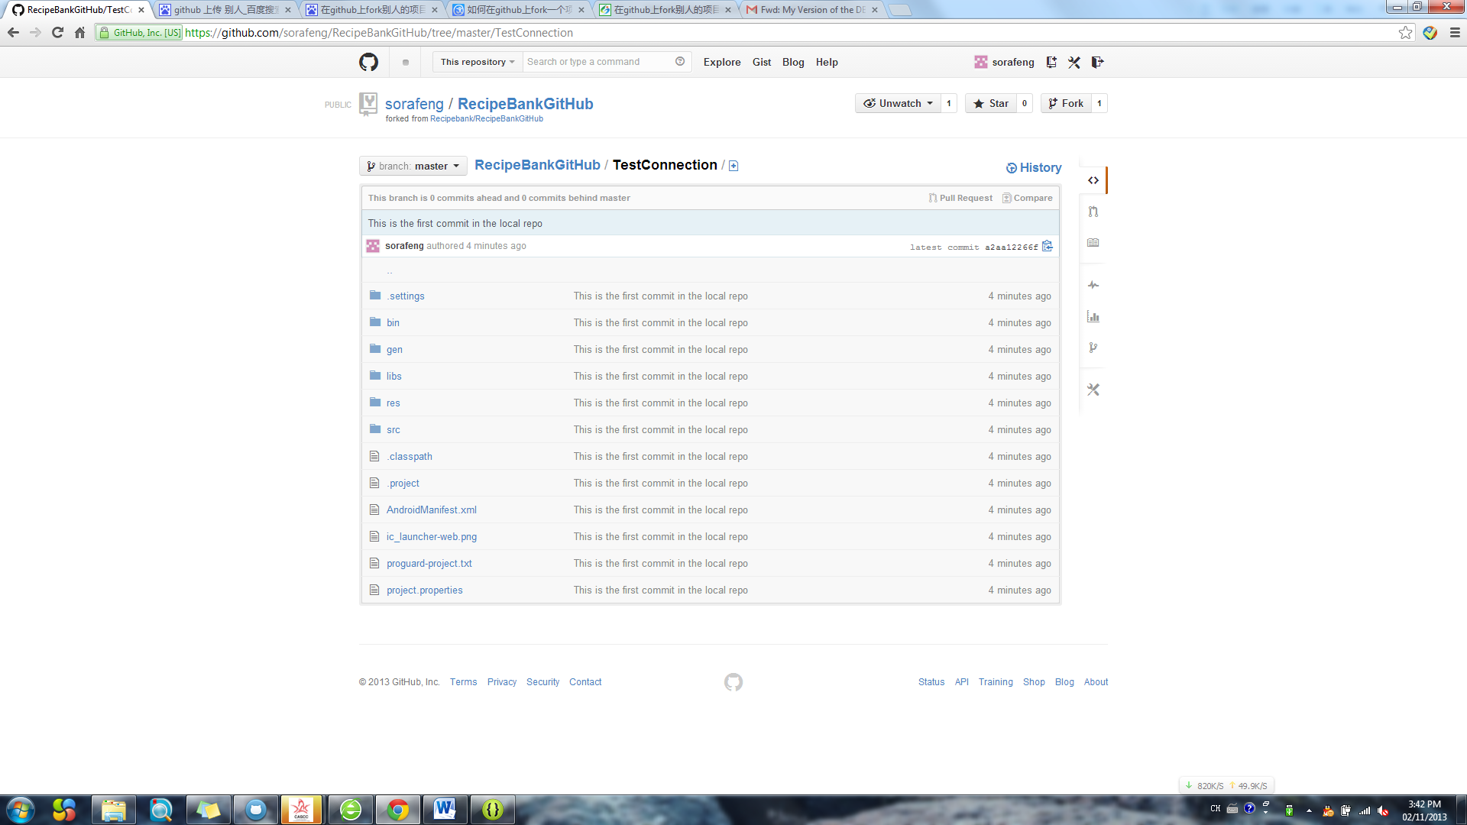

Now I want to commit my version to the project owner’s repo

Choose “Pull request”

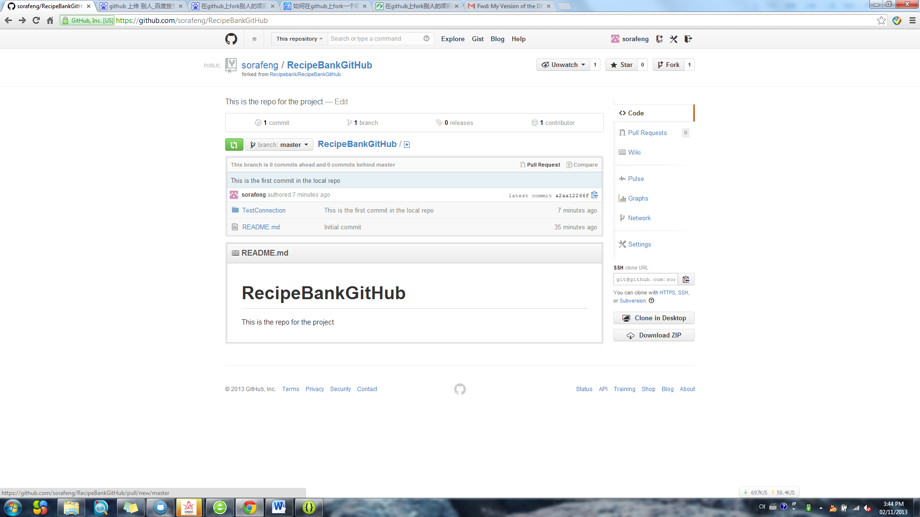

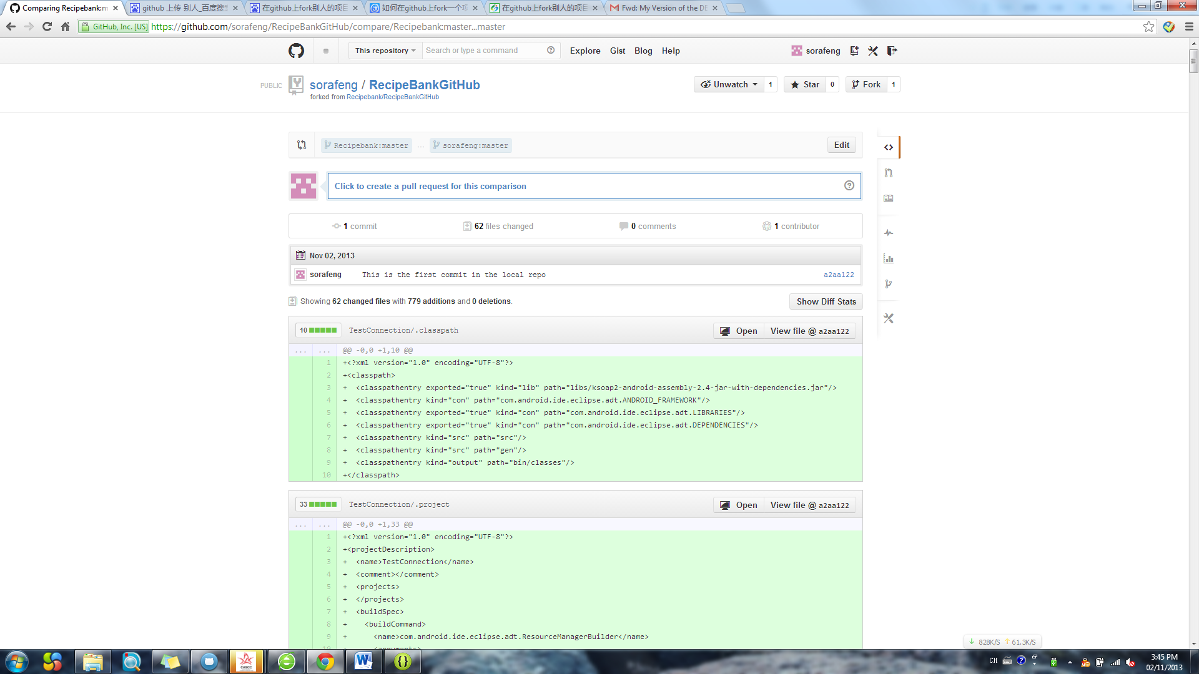

Click “Click to create a pull request for this comparison”

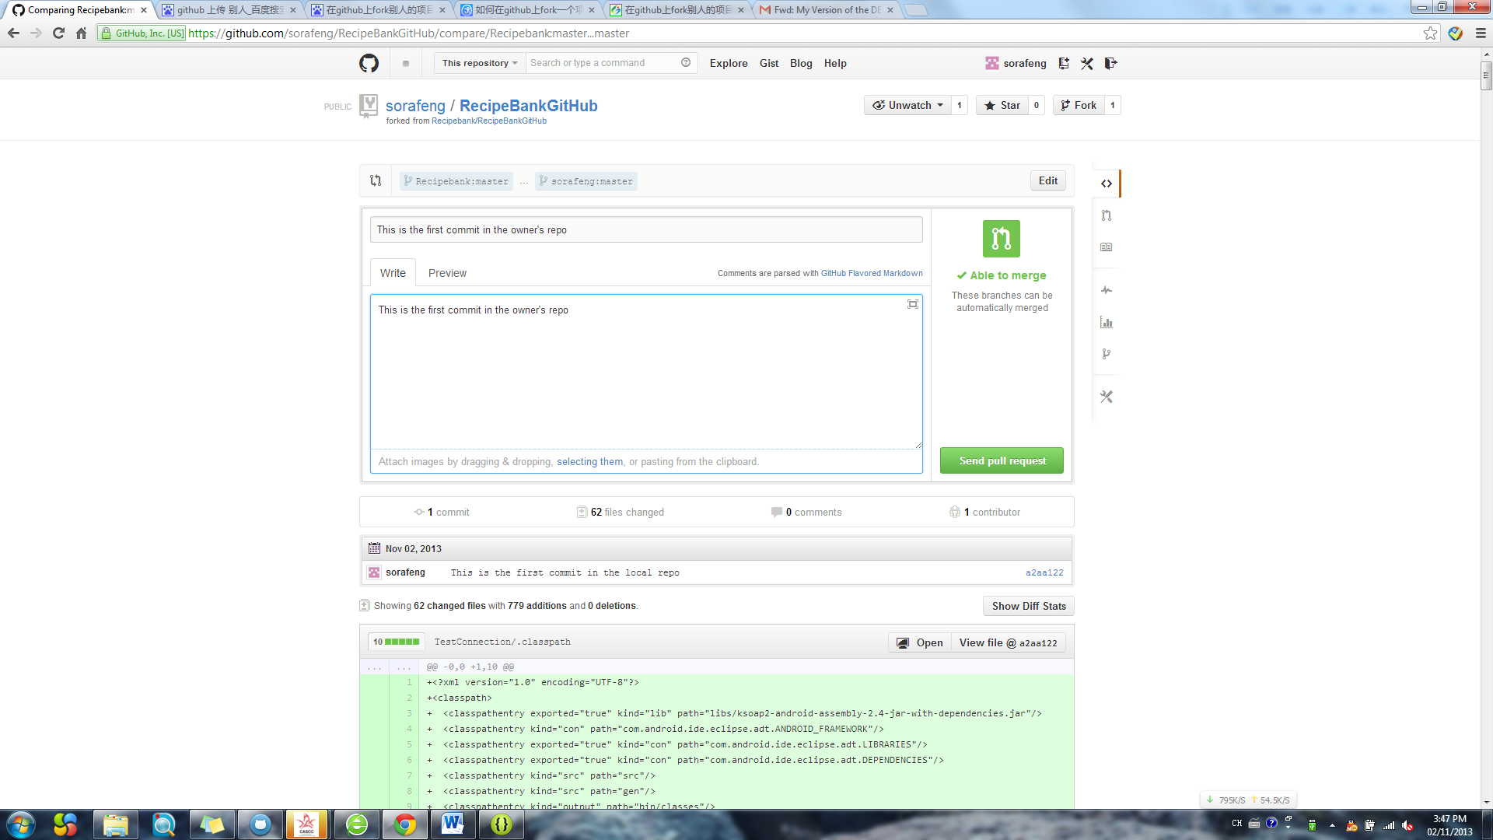

Click ”Send pull request”

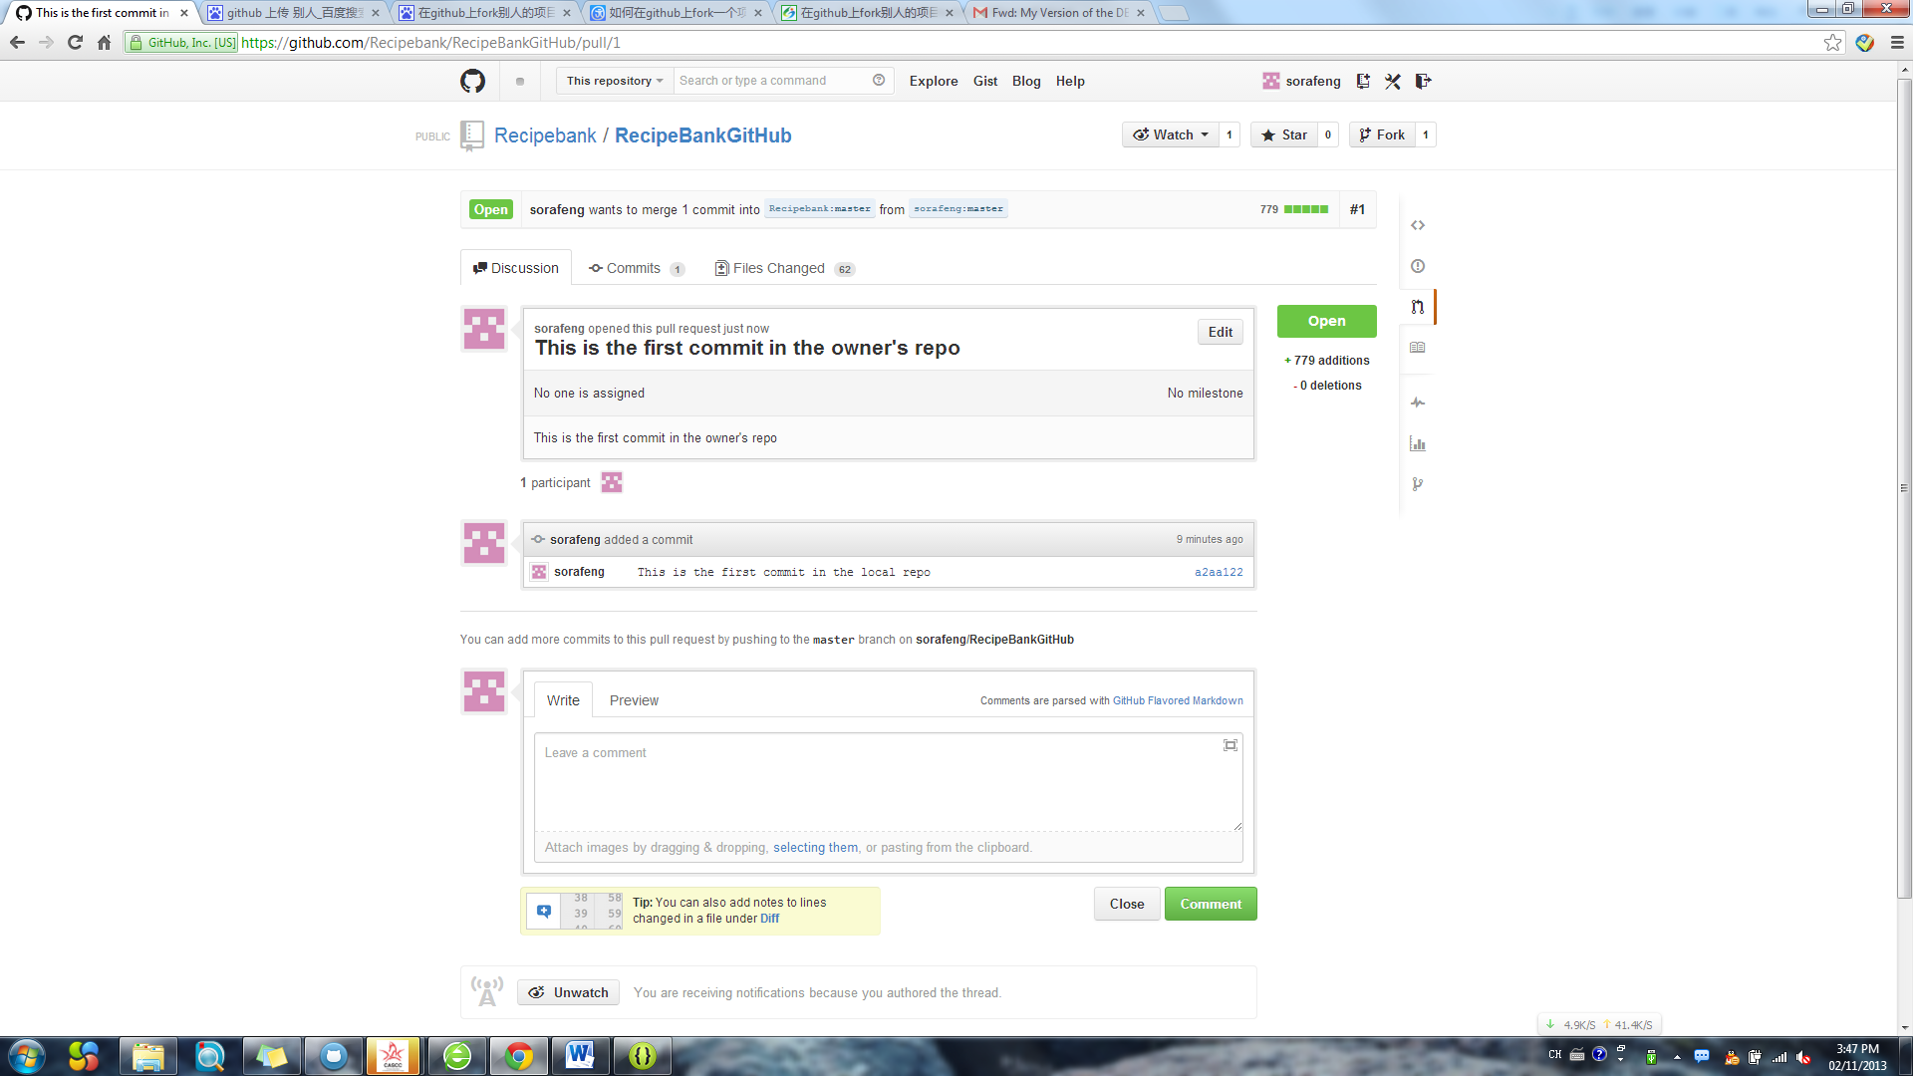

Now, your job is finish and wait for Micheal to check in and agree.

Waiting………………………………………….

Anyway, now how to keep synchronous between your repo and owner’s repo

Click “Pull Request”

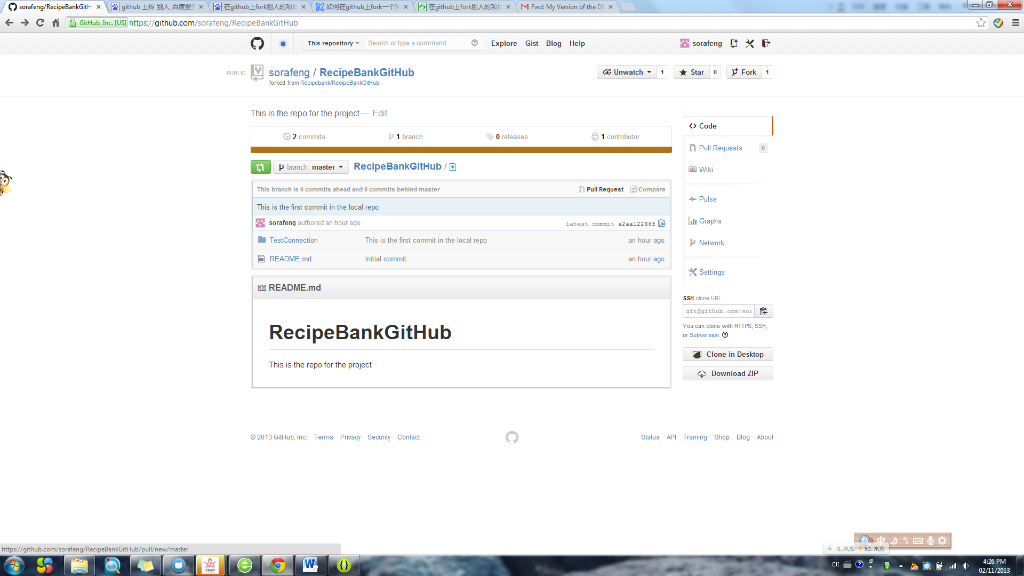 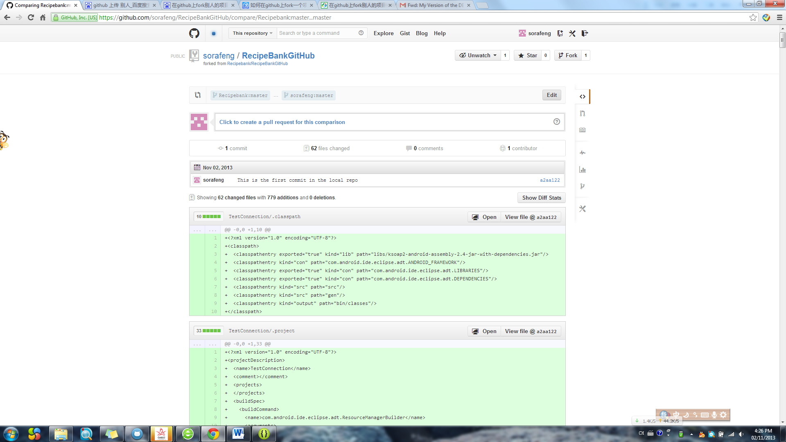

Click “Edit”

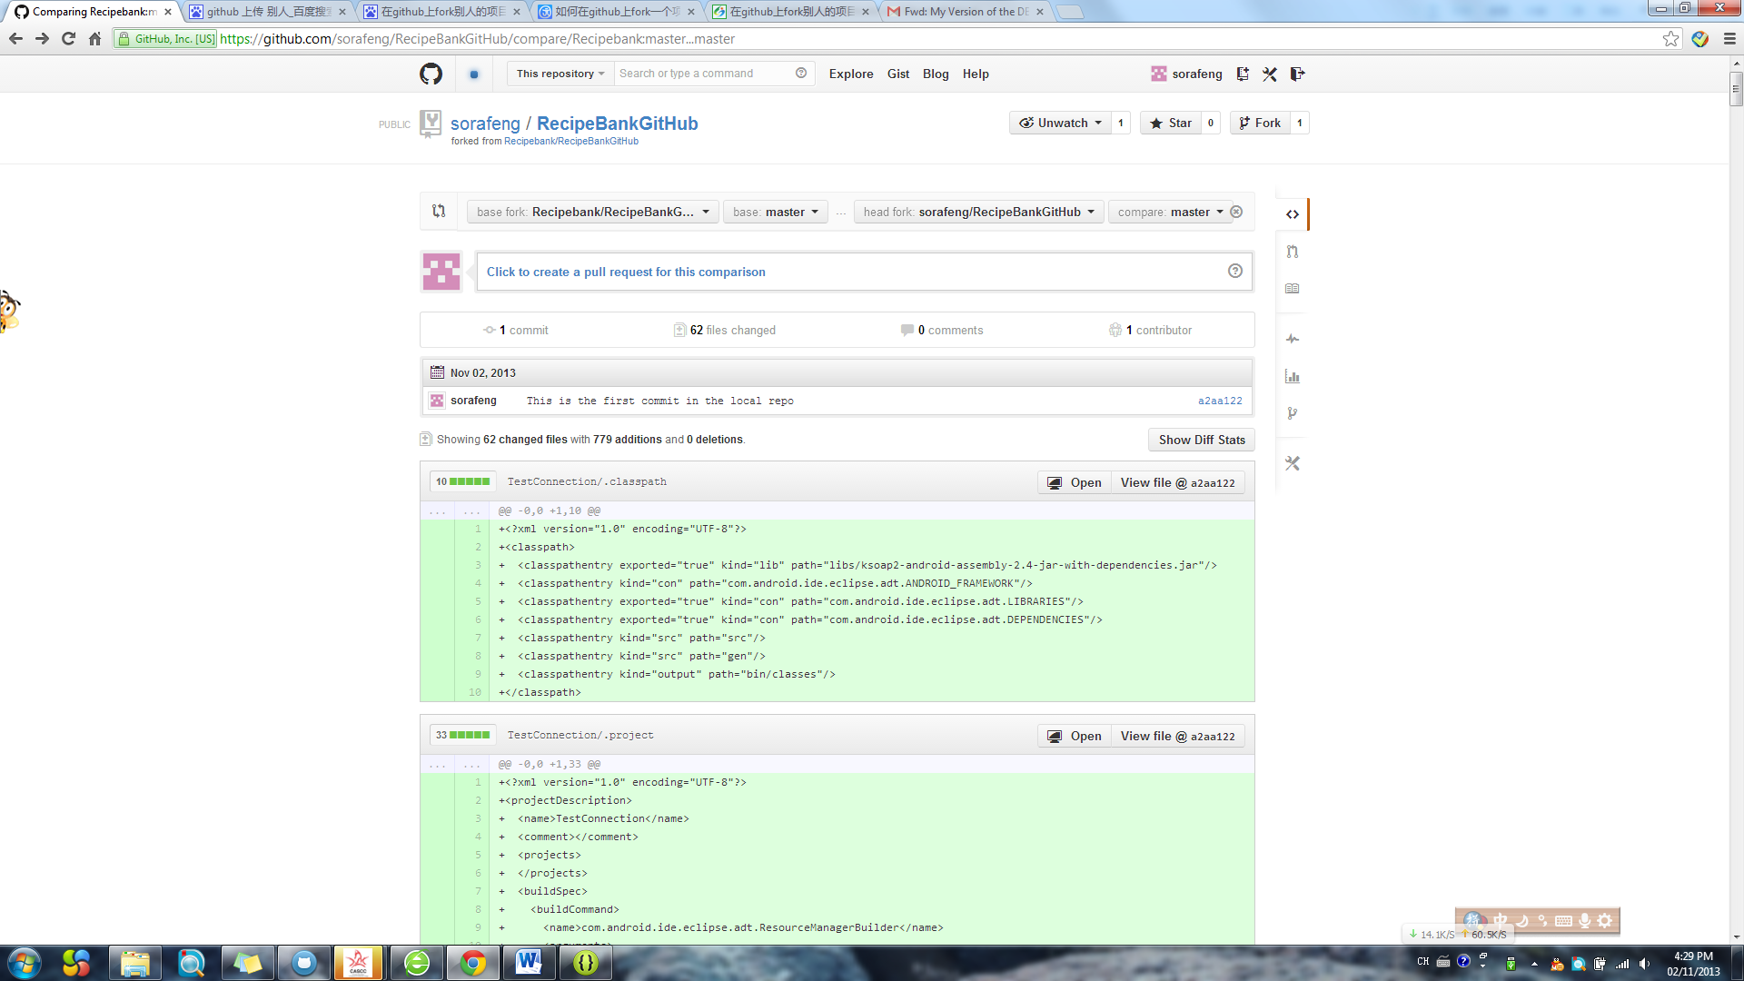

Change “head fork” to Owner’s

Change “base fork” to yours

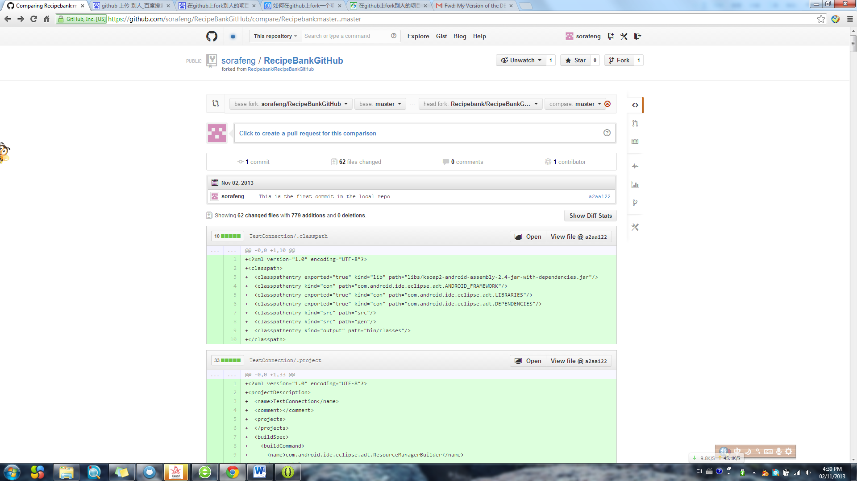

Close the edit

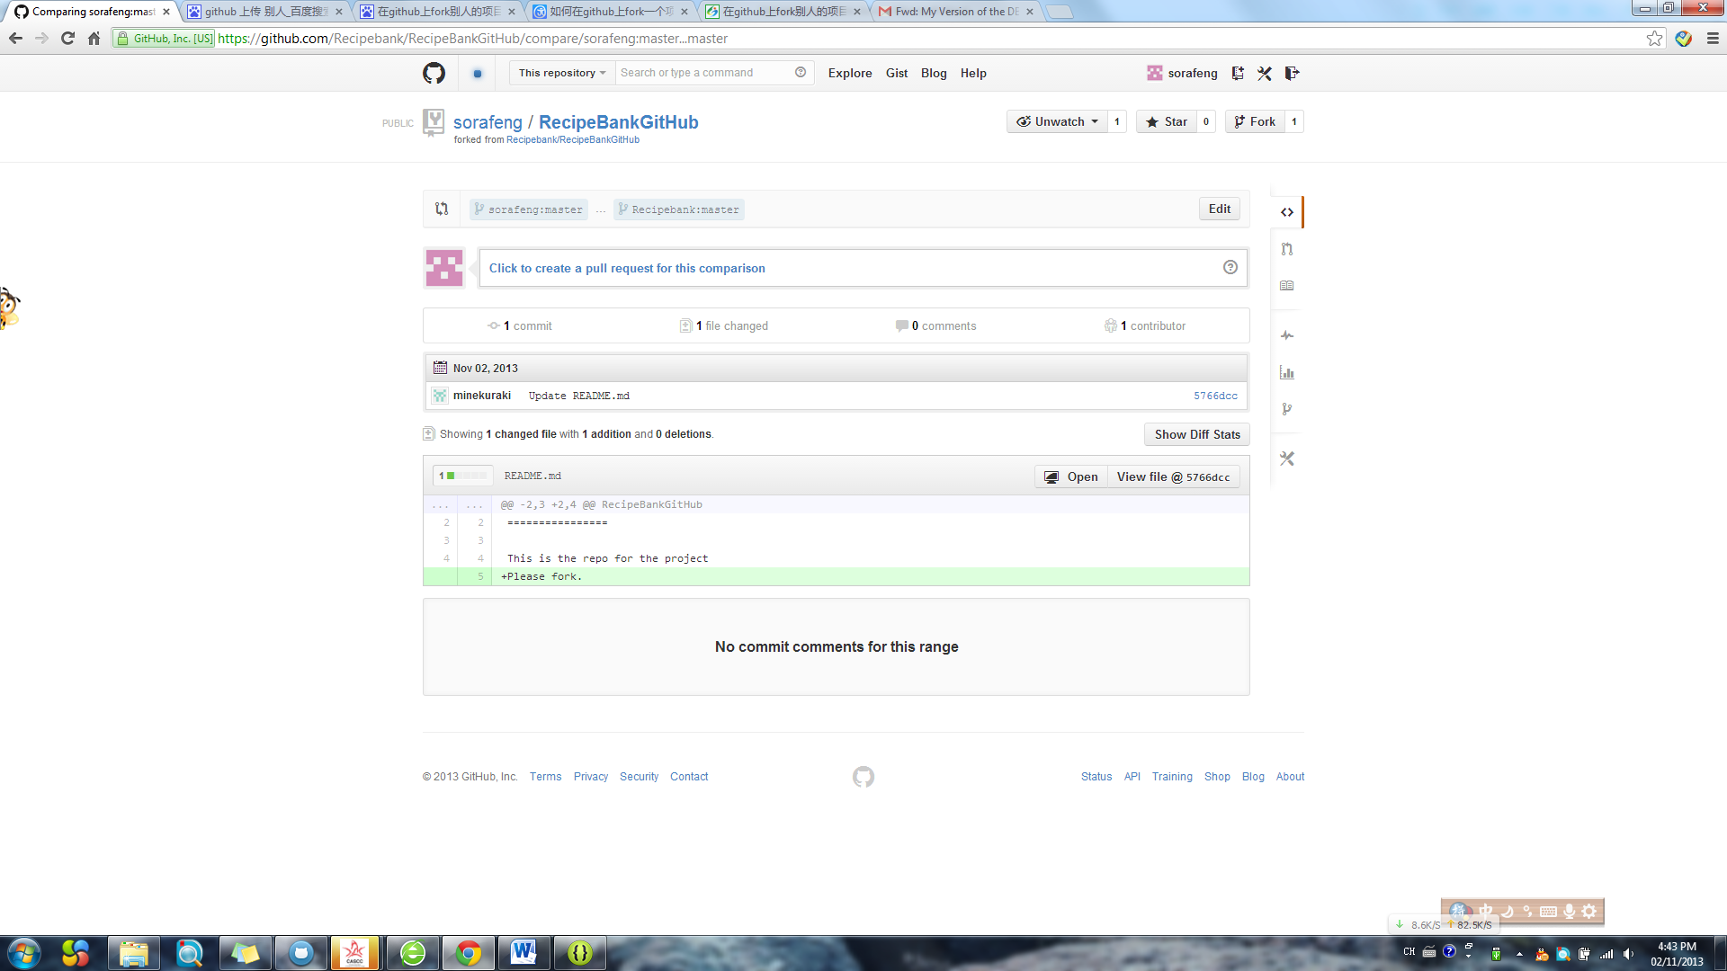

Click “Click to create a pull request…”

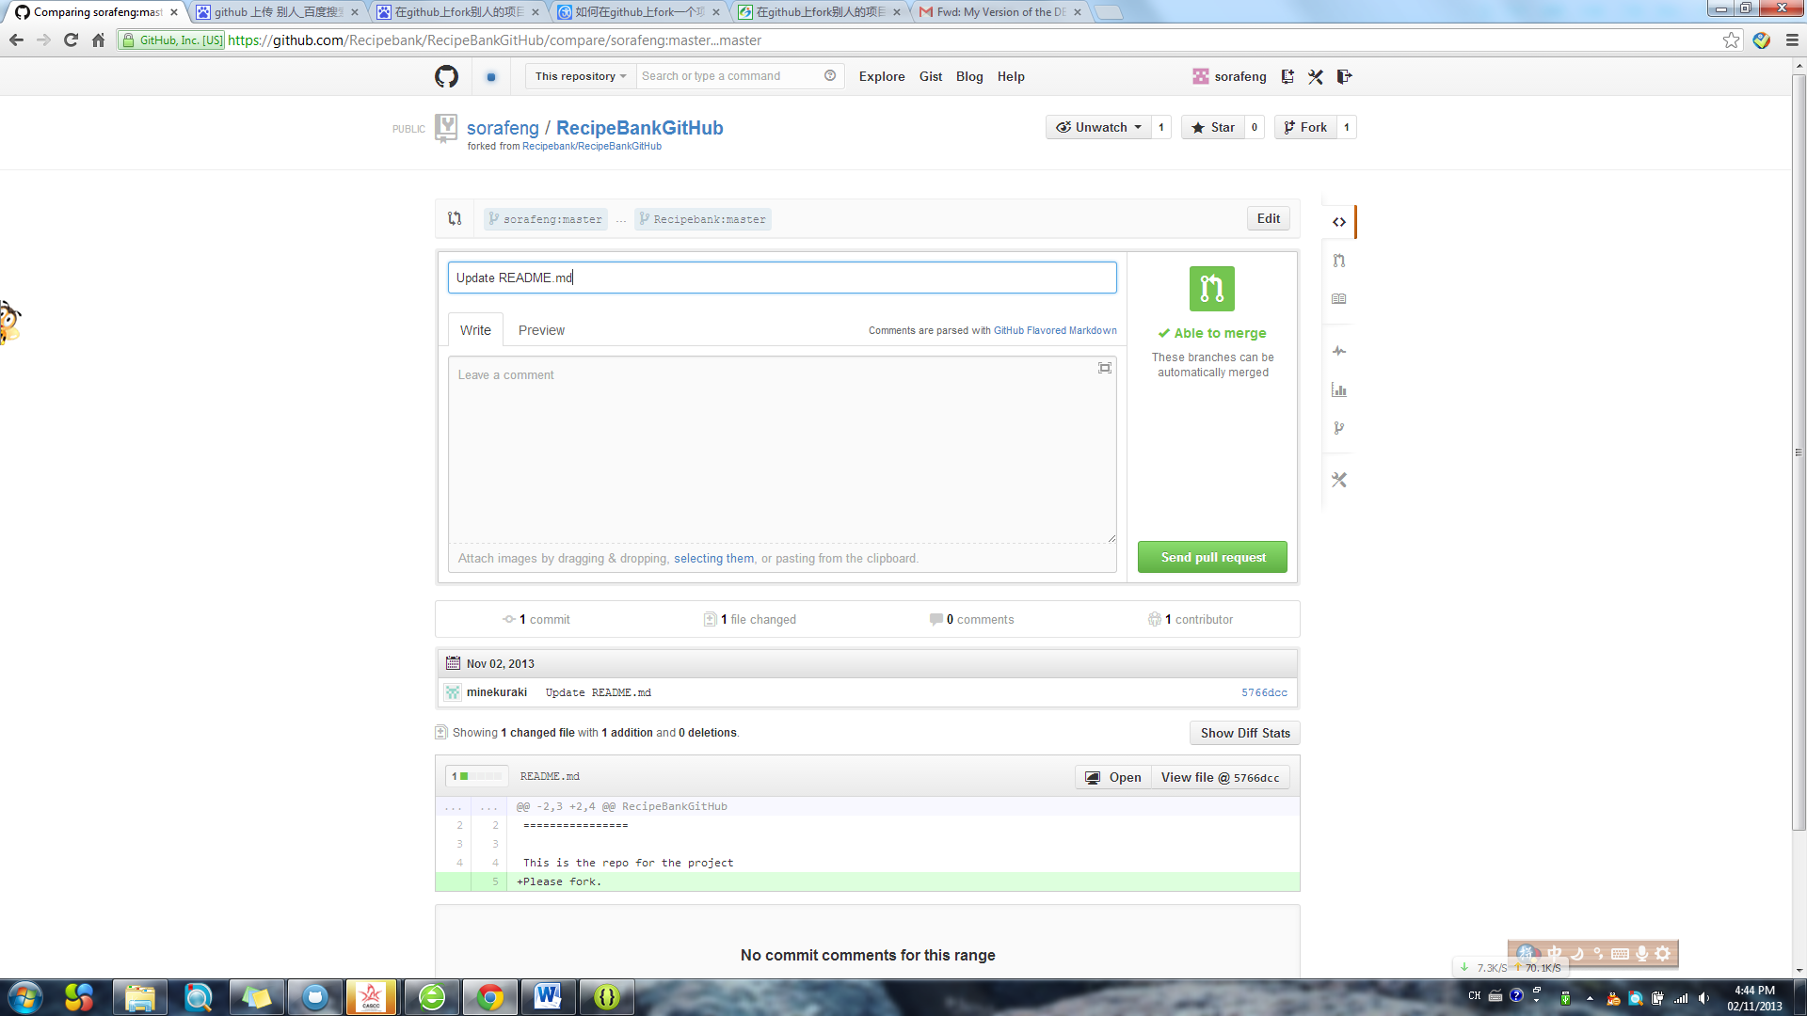

Click “Send pull Request”

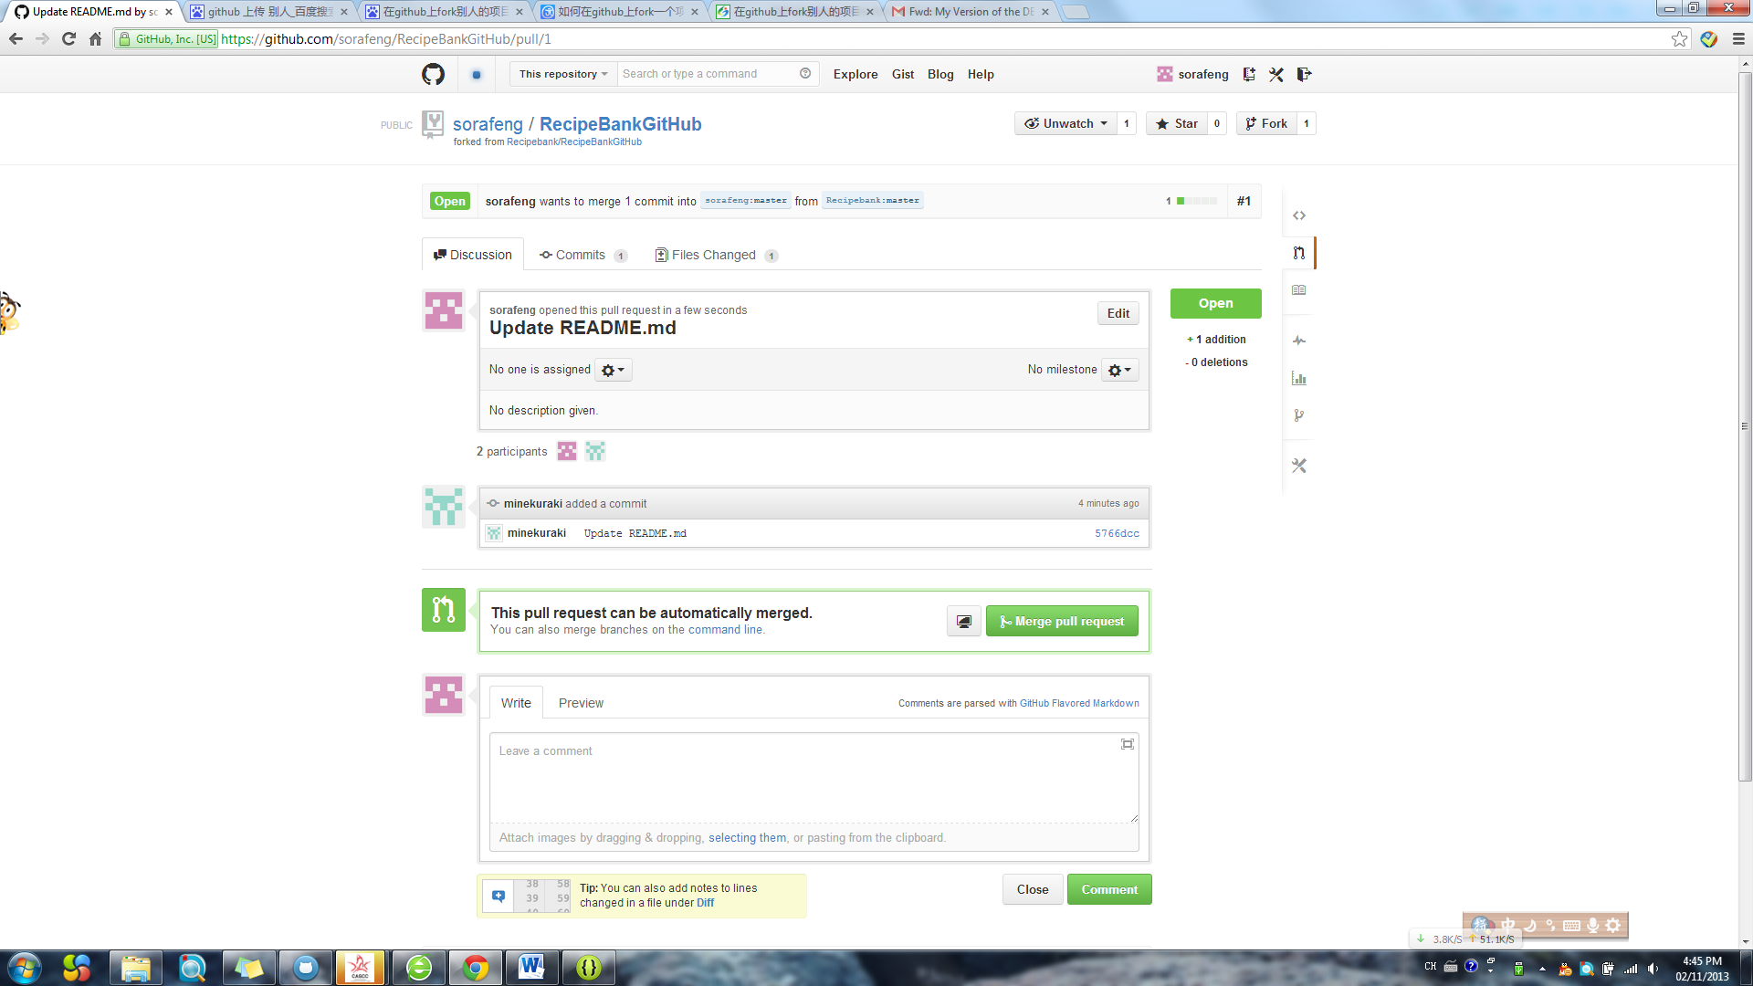

Click “Merger pull request”

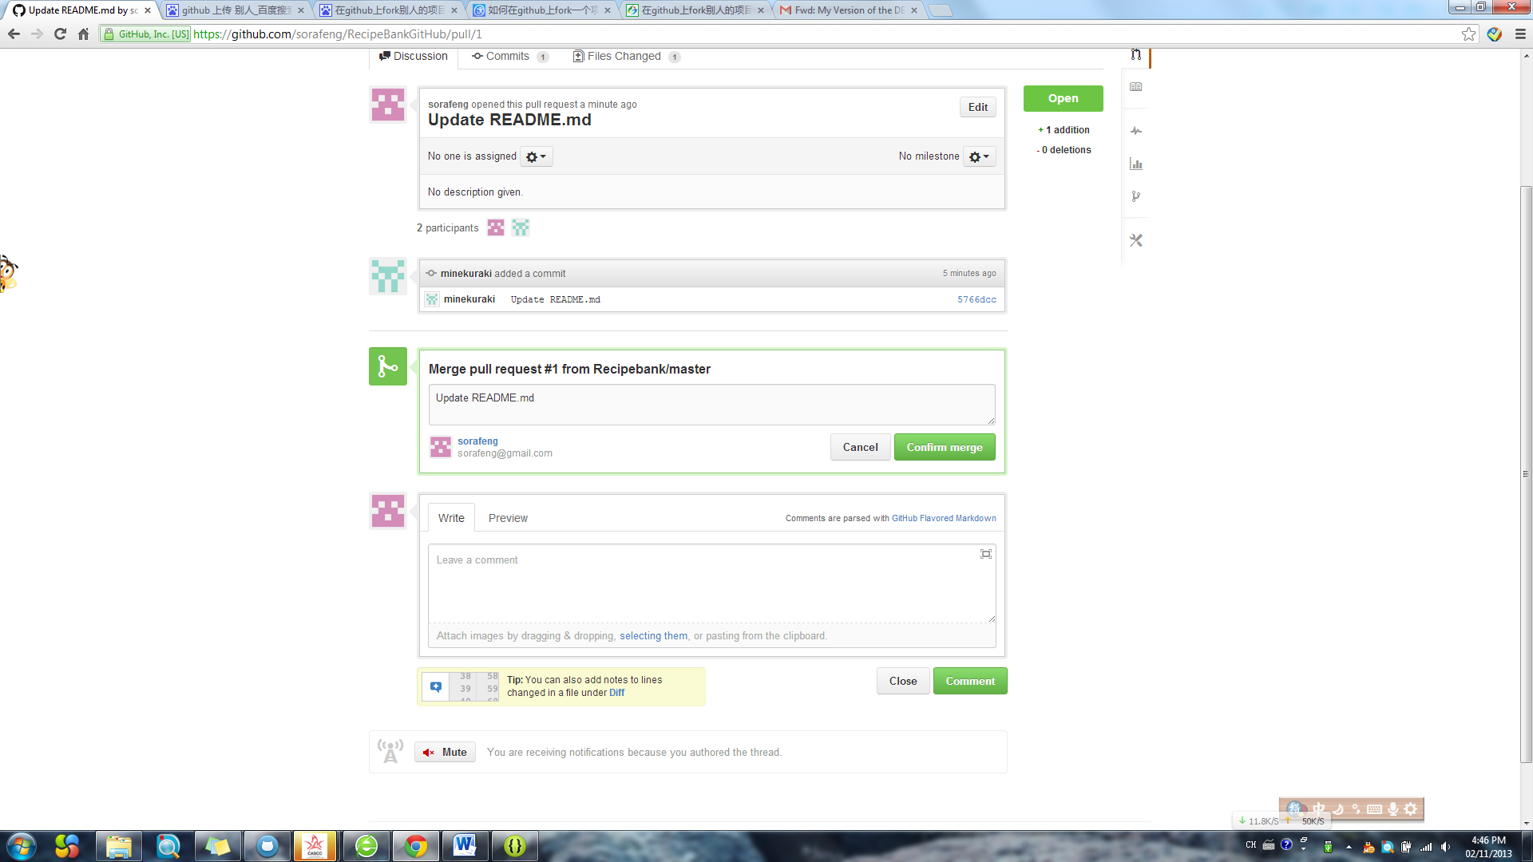

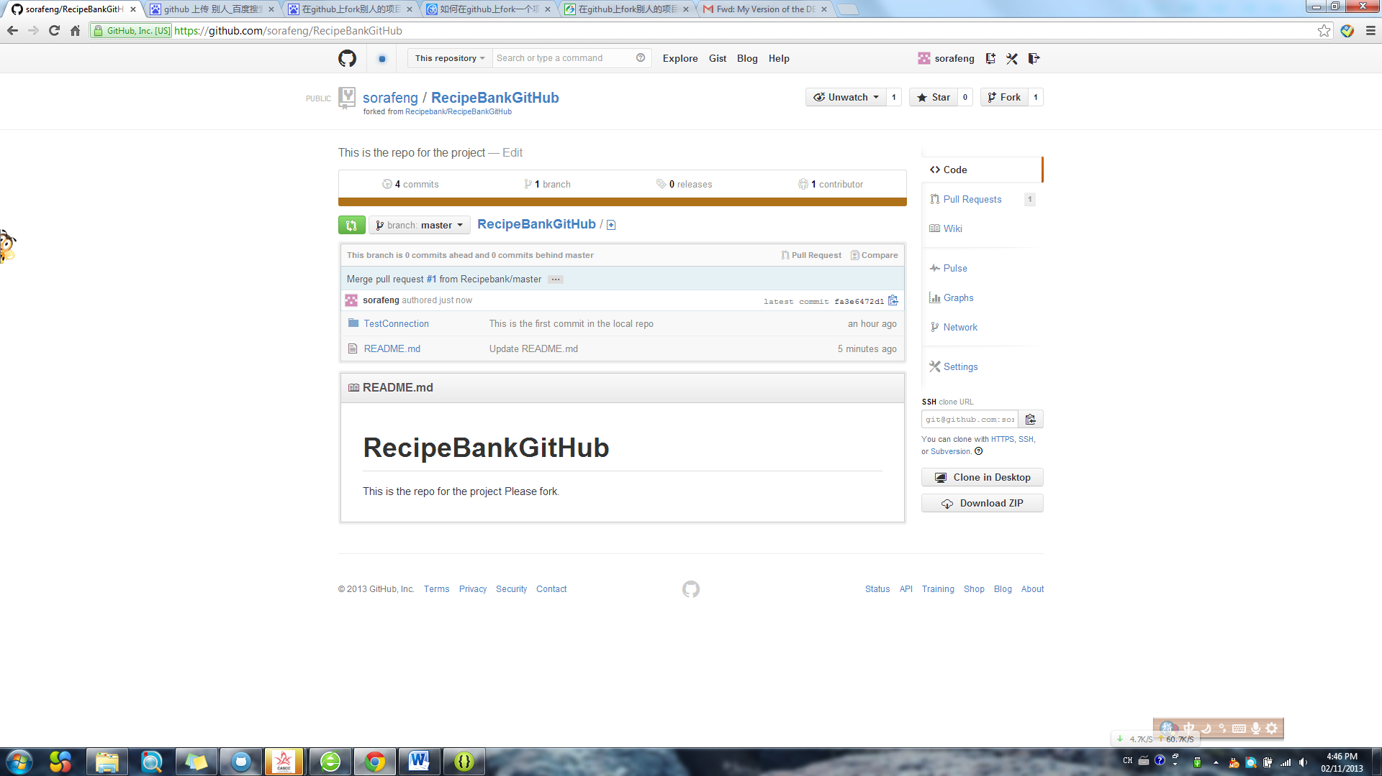

Readme already update